**DAILY ONLINE ACTIVITIES SUMMARY**

|  |  |  |  |  |  |  |  |
| --- | --- | --- | --- | --- | --- | --- | --- |
| **Date:** | **5/06/2020** | | | | **Name:** | **Samrin Banu** | |
| **Sem & Sec** | **8th B** | | | | **USN:** | **4AL16CS082** | |
| Online Test Summary | | | | | | | |
| **Subject** | | **--BDA** | | | | | |
| **Max. Marks** | | **--30** | | **Score** | | **--16** | |
| Certification Course Summary | | | | | | | |
| **Course** | **Amazon web service** | | | | | | |
| **Certificate Provider** | | | **Aws** | **Duration** | | | **3 hrs** |
| Coding Challenges | | | | | | | |
| **Problem Statement:** 1) C Program to Print traingle as pattern | | | | | | | |
| **Status: Solved** | | | | | | | |
| **Uploaded the report in Github** | | | | **YES** | | | |
| **If yes Repository name** | | | | **Samrinbanu** | | | |
| **Uploaded the report in slack** | | | | **YES** | | | |

Online test detail:

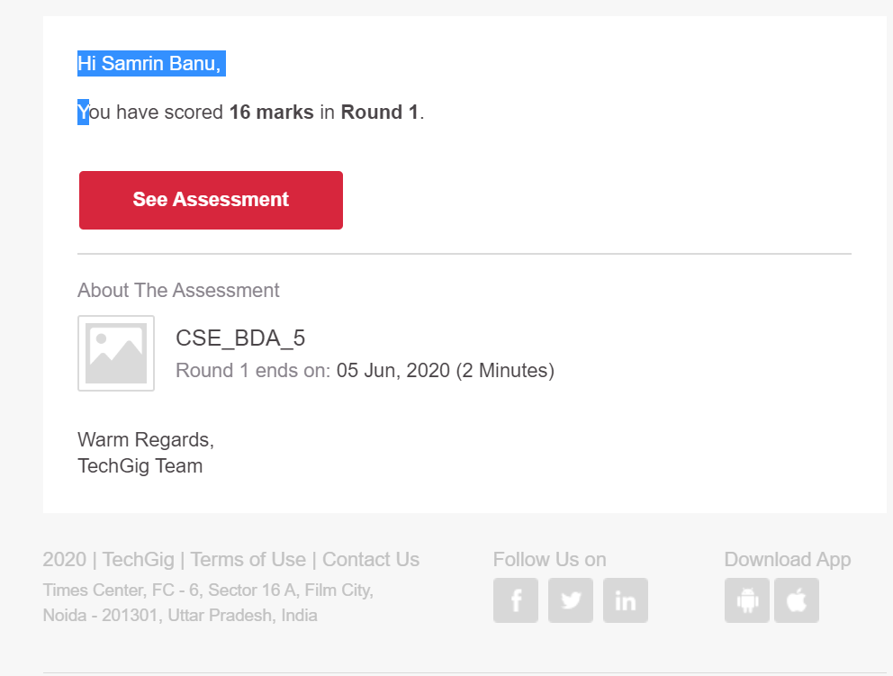

**Certification Course Details:**

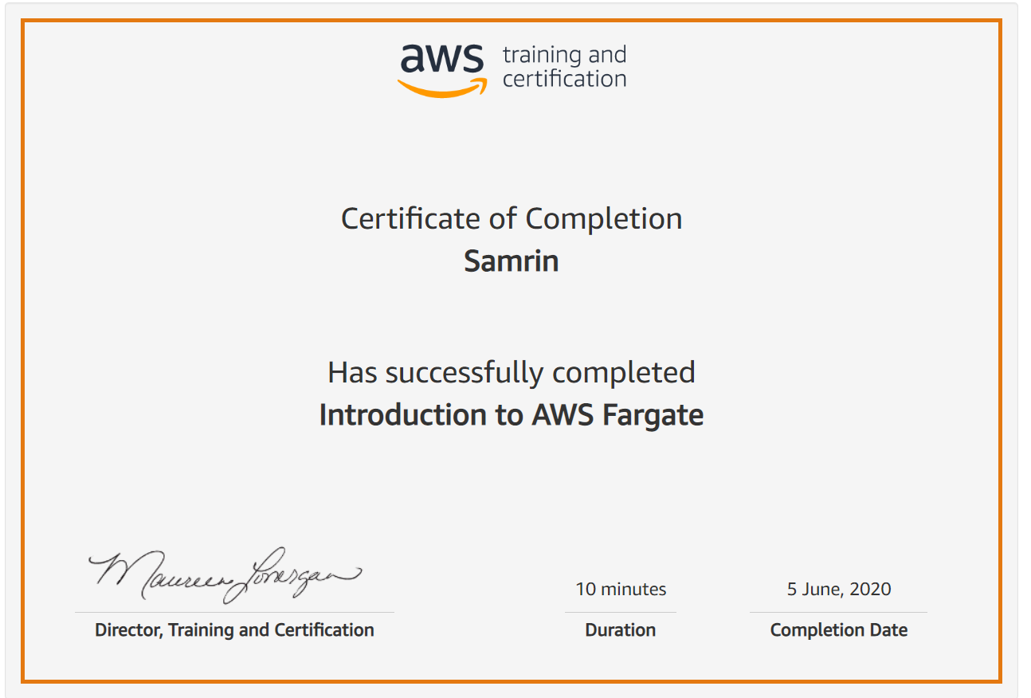

# CODE:

Program no:1

#include <stdio.h>

int main() {

int i, j;

char input, alphabet = 'A';

printf("Enter an uppercase character you want to print in the last row: ");

scanf("%c", &input);

for (i = 1; i <= (input - 'A' + 1); ++i) {

for (j = 1; j <= i; ++j) {

printf("%c ", alphabet);

}

++alphabet;

printf("\n");

}

return 0;

}